(12) At Parameters  
  
Table “former Therapies” with the fields Therapy and a second field to define the order.

* **When select some therapy and than input order, therapy from combo box missed from input. But, after added, value display again.**

(15) Multilanguage -> I need to set up the json file

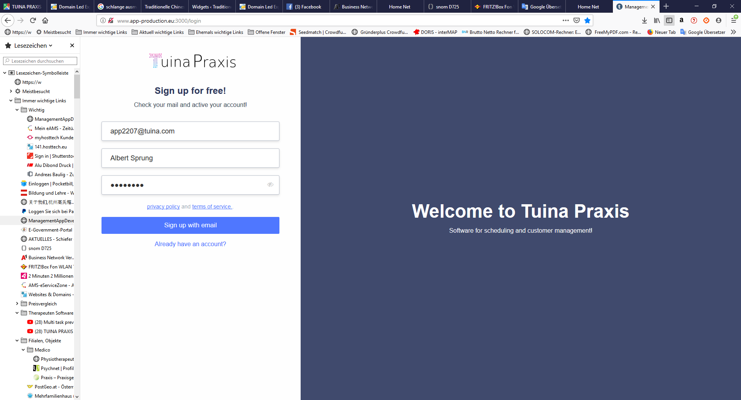

(16) After set up a new user the screen should automativally change to login screen

(20) For each store a beginning and end time for working time should be defined. For example 7:00 to 21:00. The calendar should than start at this time and end at this time. Now the calendar starts at the time that is set up at the user as working time

* After select new store, all user from previous store can be clear
* Try to fix design for time picker

(24) Once a new customer has registered all data should be empty (except parameters). Now when I register new, the customer are still there. BUT we keep that as it is and change it later, when we go online.

(26) For each store we need a field “duration of therapy”. There you can define for example 0,5h, 0,75h, 1h, 2h, etc. Than you can define the default “duration of therapy”, for example 1h. Than when a new event will be set up in the calendar, this default value (i.e. 1h) should be used.

(27) Calendar / The distance between for example 8:00 and 9:00 can be closer (maybe this can be set up at the store)

(29) Later we need some reference-companies from where initially can be overtaken the parameters

(30) For customers and Doctors we need an import-function

* What import function

(31)

Customer

Complaint

Therapy

Document

* Once a Complaint / Therapy / Document is added, it should be able to edit/change it
* Show document after upload
* Change localhost:3000 with app-production.eu:3000

(32) Order of the calendars should be always the same like I added the users

i.e. I add first Albert, then Karin and then Jeff and now   
the calendars are from left to right Albert, then Karin and then Jeff

(33) 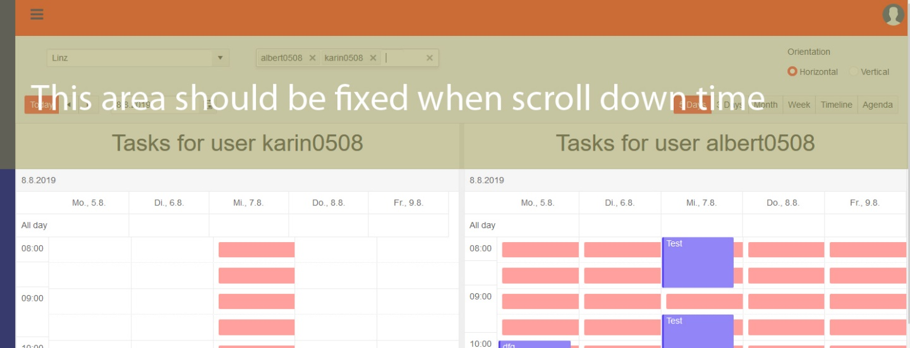

When scroll down the area on the top should be fixed and should not scroll

(34) Customer data should be editable

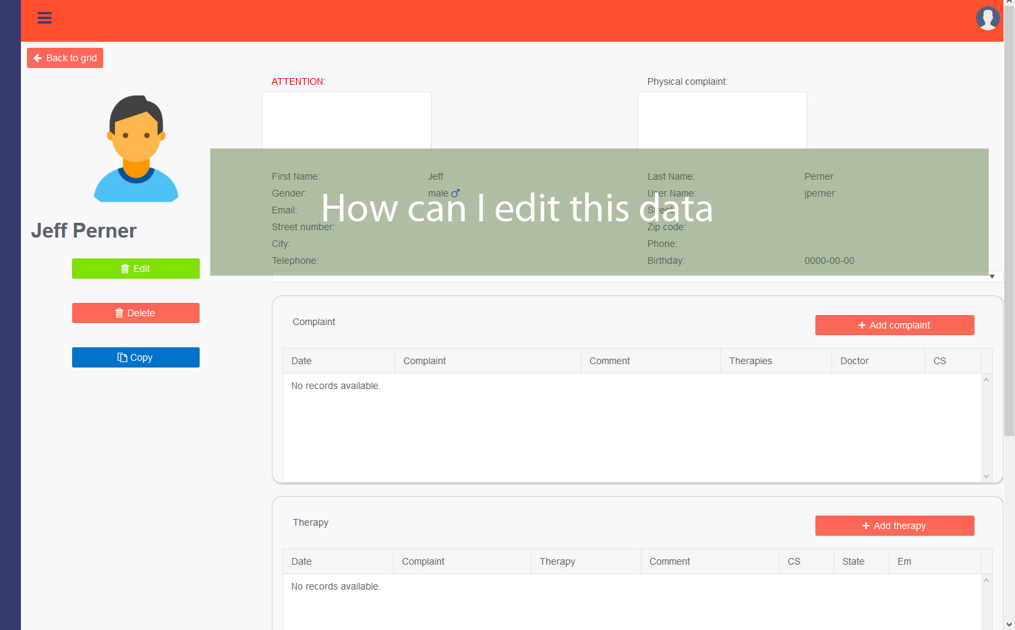

* This part can be edit. Just click on edit. Need to add some new filed for edit.

(35)

Customer // the following fields are missing (defined in parameters):

Recommendation

relationship status

social insurance

doctors

* **This is part of Base data I**



But it seems that you have forgotten to give names to the different sections.

Please look at the screenshot: You have to give all input fields names. Nobody knows what is in that fields.

(one more time: you should check the things before you upload them – that saves a lot of time and frustration for me and speed up the project)

* **This should have, but language maybe don’t upload**

(36) One task is that the timeline is not correct (8.00, 9.00 etc. are not synchroneous with the next row).



The time (14:00, 16:00, 21:00, etc. is not in the same position like the next rows and not like the next calendar

* Task for all day don’t show

(37)

Only two calendars are working parallel

* Tell it to record it for you

(38)  
If a new user is set up, all users of the same store should be shown at the calendar and the order of the calendars should be the same like the order in the field of selection of the users (now it is sometimes different)